# Year 1 trainee GastroIntestinal pathology slide seminar handout

# Slide 1a: Gastric antral endoscopic biopsy – normal (Figure A)

This sort of specimen will contain: mucosa +/- muscularis mucosae +/- submucosa

Mucosa = surface/pit/gland epithelium + lamina propria

## Epithelium

* Throughout the stomach, surface and pit epithelium is foveolar epithelium.
* In gastric antrum, gland epithelium is mucus-secreting epithelium.

## Lamina propria

* Contents include: chronic inflammatory cells + blood vessels + lymphatics (just superficial to muscularis mucosae) + smooth muscle fibres
* Normal inflammatory cell population includes: lymphocytes + macrophages + plasma cells + mast cells



# Slide 1b: Gastric antral endoscopic biopsy - Helicobacter-related gastritis (Figure B)

Main abnormalities seen in this case:

* Increased chronic inflammatory cells in lamina propria
* Neutrophils in epithelium and lamina propria (Figure C)
* Helicobacter organisms
* [Not shown in this case but may also see: gland atrophy +/- intestinal metaplasia]

# Year 1 trainee GastroIntestinal pathology slide seminar handout

# Slide 2a: Duodenal endoscopic biopsy – normal (Figure D)

This sort of specimen will contain: mucosa +/- muscularis mucosae +/- submucosa

Mucosa = villous/surface/crypt epithelium + lamina propria

## Epithelium

* Villous, surface and crypt epithelium (+/- Brunner’s glands)
* Crypt epithelium = goblet cells + absorptive cells + endocrine cells + Paneth cells

## Lamina propria

* Contents include: chronic inflammatory cells + blood vessels + lymphatics + smooth muscle fibres
* Normal inflammatory cell population includes: lymphocytes + macrophages + plasma cells + eosinophils + mast cells

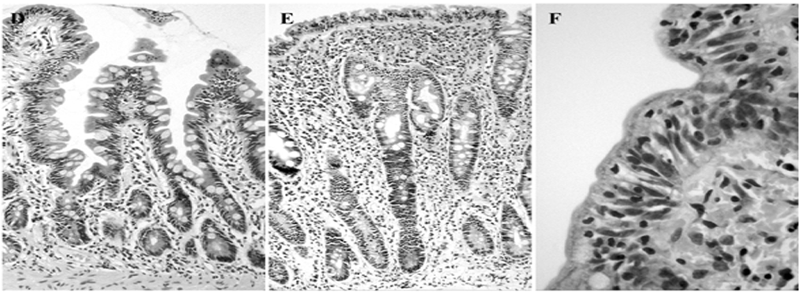

# Slide 2b: Duodenal endoscopic biopsy – coeliac disease (Figure E)

Main abnormalities seen in this case:

* Increased chronic inflammatory cells in lamina propria
* Increased lymphocytes in epithelium (> 25 per 100 epithelial cells, Figure F)
* Villous atrophy
* Crypt hyperplasia

# Year 1 trainee GastroIntestinal pathology slide seminar handout

# Slide 3a: Colorectal resection specimen – normal (Figure G) and adenoma

This sort of specimen will contain: mucosa + muscularis mucosae + submucosa + muscularis propria +/- subserosa + serosa (also known as visceral peritoneum)

Mucosa = surface/crypt epithelium + lamina propria

## Epithelium

* Surface and crypt epithelium
* Crypt epithelium = goblet cells + absorptive cells + endocrine cells +/- Paneth cells

## Lamina propria

* Contents include: chronic inflammatory cells + blood vessels + lymphatics (just superficial to muscularis mucosae) + smooth muscle fibres
* Normal inflammatory cell population includes: lymphocytes + macrophages + plasma cells + eosinophils + mast cells

## **Adenoma**

Main abnormalities seen in this case:

* Cellular abnormalities (i.e. dysplasia)
* Abnormal crypts (tubular component, Figure H)
* Villus formation (villous component, Figure I)



# Year 1 trainee GastroIntestinal pathology slide seminar handout

# Slide 3b: Colorectal resection specimen – normal (Figure J) and adenocarcinoma

This sort of specimen will contain: mucosa + muscularis mucosae + submucosa + muscularis propria +/- subserosa + serosa (also known as visceral peritoneum)

## **Adenocarcinoma**

Main abnormalities seen in this case:

* Cellular & architectural abnormalities (Figure K)
* Invasion of tissues (lamina propria + muscularis mucosae + submucosa + muscularis propria, Figure L)
* [Not shown in this case but may also see: invasion of lymphatic/blood vessels +/- metastases, e.g. in lymph nodes]

